**Documentation System**

**Web Based Online Application Management for OJT Applicants in Dota Aero Aviation Corporation**

**Links**

[LaffeyTaffey/Web-based-Online-Application-Management-for-OJT-Applicants-in-Dota-Aero-Aviation-Corporation: A thesis project (github.com)](https://github.com/LaffeyTaffey/Web-based-Online-Application-Management-for-OJT-Applicants-in-Dota-Aero-Aviation-Corporation)

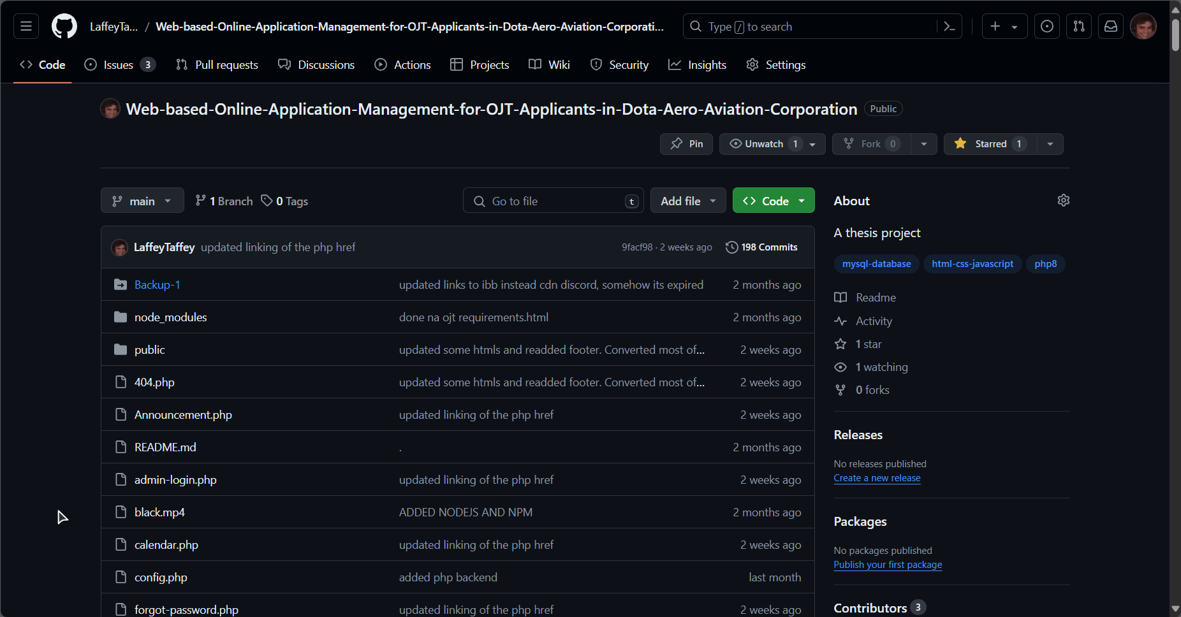

[**https://drive.google.com/drive/folders/1LdsYfnYTb3fpxcS0d9MOcF5sj8OyhHTN?usp=drive_link**](https://drive.google.com/drive/folders/1LdsYfnYTb3fpxcS0d9MOcF5sj8OyhHTN?usp=drive_link)

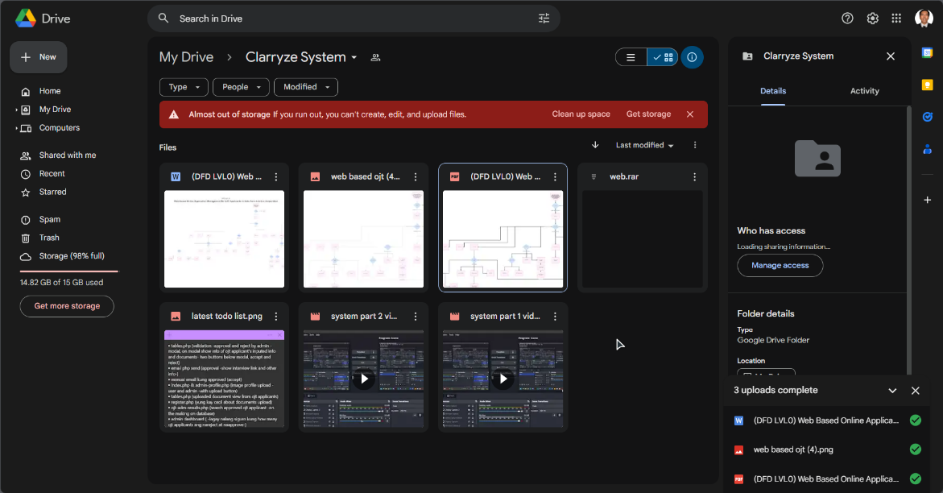

**Requirements**

**1. VS CODE**

Download link: <https://code.visualstudio.com/sha/download?build=stable&os=win32-x64-user>

Note: only use vscode if you want to edit the codes of our system.

Setup vscode:

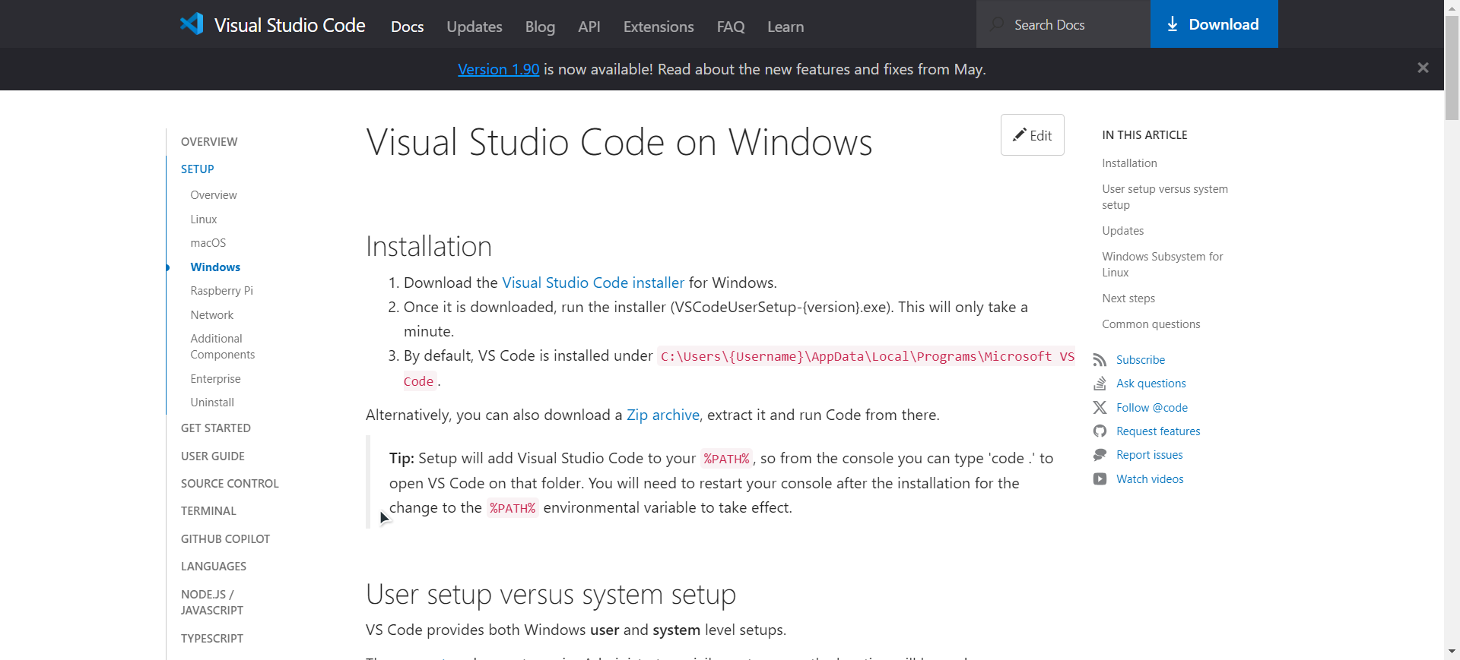

**2. XAMPP (most important, if you want to just run the system)**

Download link: <https://sourceforge.net/projects/xampp/files/XAMPP%20Windows/8.2.12/xampp-windows-x64-8.2.12-0-VS16-installer.exe>

Setup:

3. DRIFT live chat (you can use the website to chat with the ojt applicants without hassle of installing the desktop app)

Download link:

<https://drift-prod-desktop-installers.s3.amazonaws.com/win/DriftSetup-latest.exe>

**>>>>>>>>>>Notes<<<<<<<<<<**

1. On the calendar, to add events to the system for the ojt applicants use this login information:

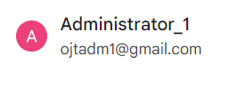

Address: [ojtadm1@gmail.com](mailto:ojtadm1@gmail.com)

Password: OJTADMINISTRATORSYSTEM2

**cmcz iwcy mazh rycn**

To edit and add events/activities, goto this link:

<https://calendar.google.com/calendar/u/0/r>

2. On the DRIFT (LIVE CHAT), to chat with the applicants, download the DRIFT CHAT APPLICATION AND USE THIS LOGIN INFORMATION

IF THE PANELIST WANTS TO KNOW IF THE LIVE CHAT WORKS, DO THIS STEPS BELOW:

**LOGIN INFO:**

To login: <https://start.drift.com/login>

(Click sign in with Google if you used [ojtadm1@gmail.com](mailto:ojtadm1@gmail.com) login information)

**Website login:**

Goto: <https://app.drift.com/home/dashboard>

And just sign in using your [ojtadm1@gmail.com](mailto:ojtadm1@gmail.com) (sign in with google)

If there is a new visitor just chat with them.

**PC app installation & login:**

DOWNLOAD THE APP:  
<https://drift-prod-desktop-installers.s3.amazonaws.com/win/DriftSetup-latest.exe>

SETUP THE APP:

. Go to your download page and Double click the exe file

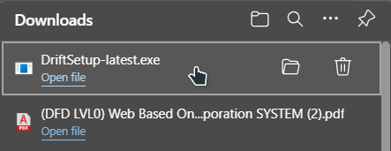

. Let it install

. Login in to your drift account using google [ojtadm1@gmail.com](mailto:ojtadm1@gmail.com) (don’t forget to login to the google account first)

. new conversations will automatically appear if someone chatted on the live chat.

3. To edit the “submit a ticket webpage” google forms contents, use this link:

<https://docs.google.com/forms/d/12_xkVY3uzFwl8VGm2eylctHOPmYuNkXBHNh0xPbaDQs/edit>

**System Contents**

1. **Landing Page**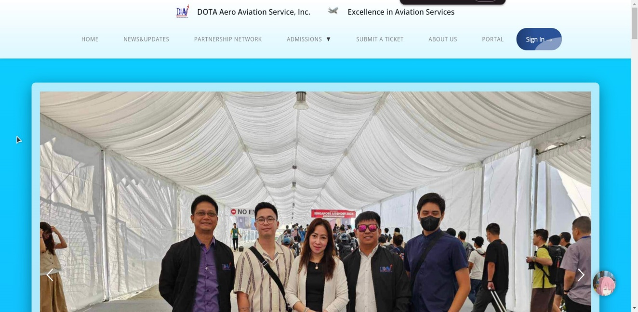

The landing page of the system serves as the hub of the contents of the system. It consists of the Home, news & updates, partnership network, admissions (credentials, OJT Admission, OJT Admission Results), submit a ticket, about us, portal and the sign in buttons. Header navigation design are inspired from <https://www.oneplus.com/ph>

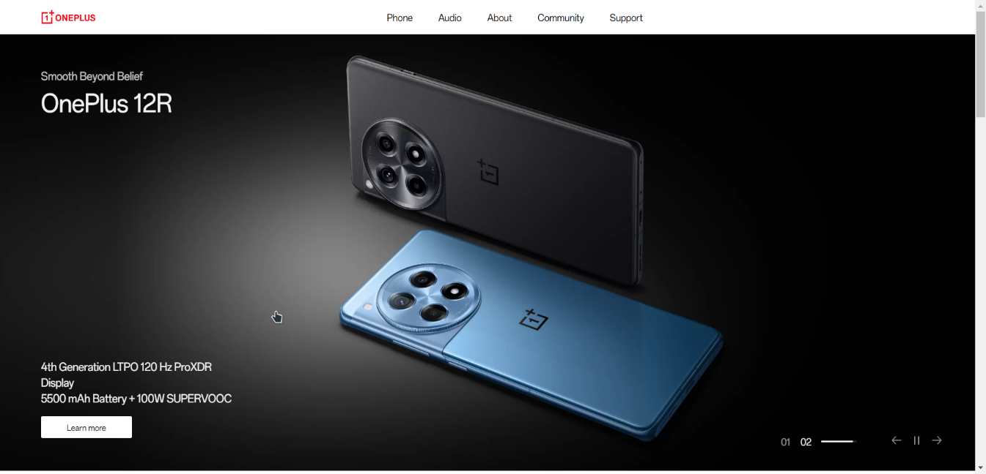

1. **News & Updates**

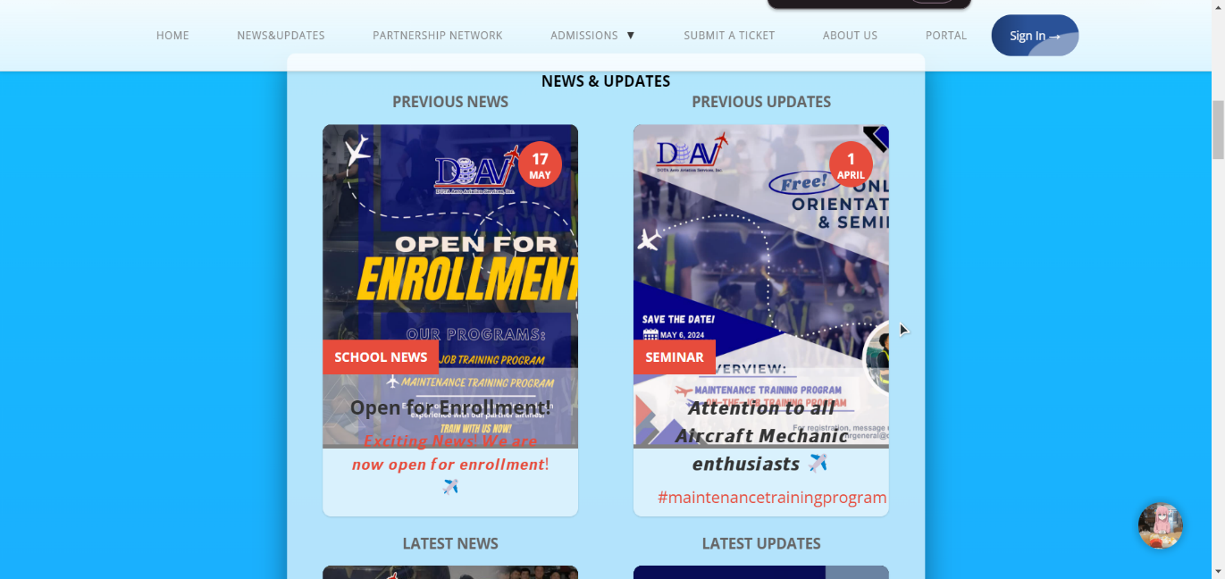

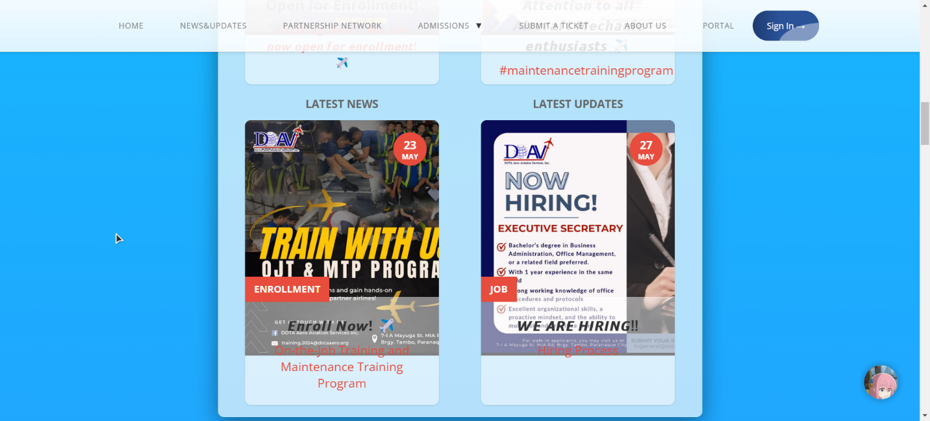

This part of the landing page contains the Previous news/ updates and the Latest news/updates of either for DOTA and related to the OJT programs. It is not server sided and can only be edited locally. Information been taken from DOTA’S fb page: [**https://www.facebook.com/profile.php?id=100063697941857**](https://www.facebook.com/profile.php?id=100063697941857)

1. **Partnership Network**

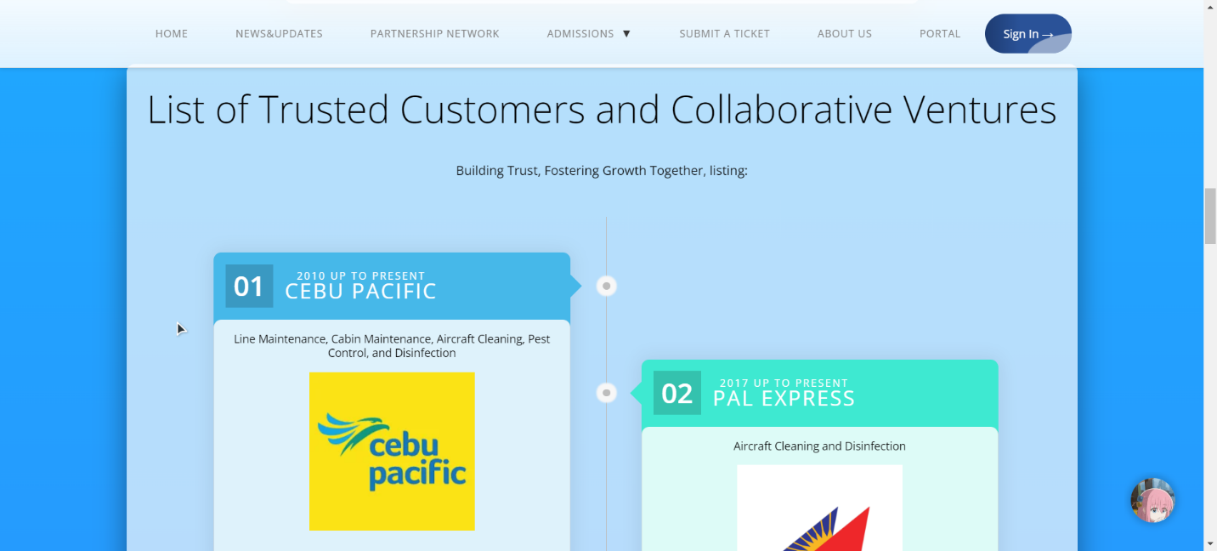

Partnership network part contains and lists the trusted customers and collaborative ventures from many companies. Design choice inspired from <https://venngage.com/blog/timeline-template/>

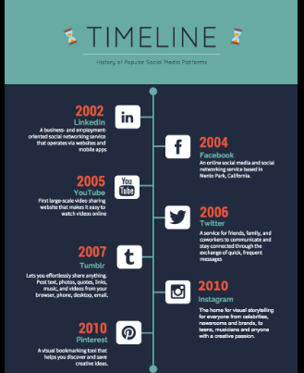

The list of trusted customers and collaborative ventures Information are obtained from [DOTA Aero | (dota-aero.com)](https://dota-aero.com/)

**4. Credentials**

**Certified excellence: empowering trust in every credential contains every credential obtained by DOTA AERO AVIATION SERVICES, INC.**

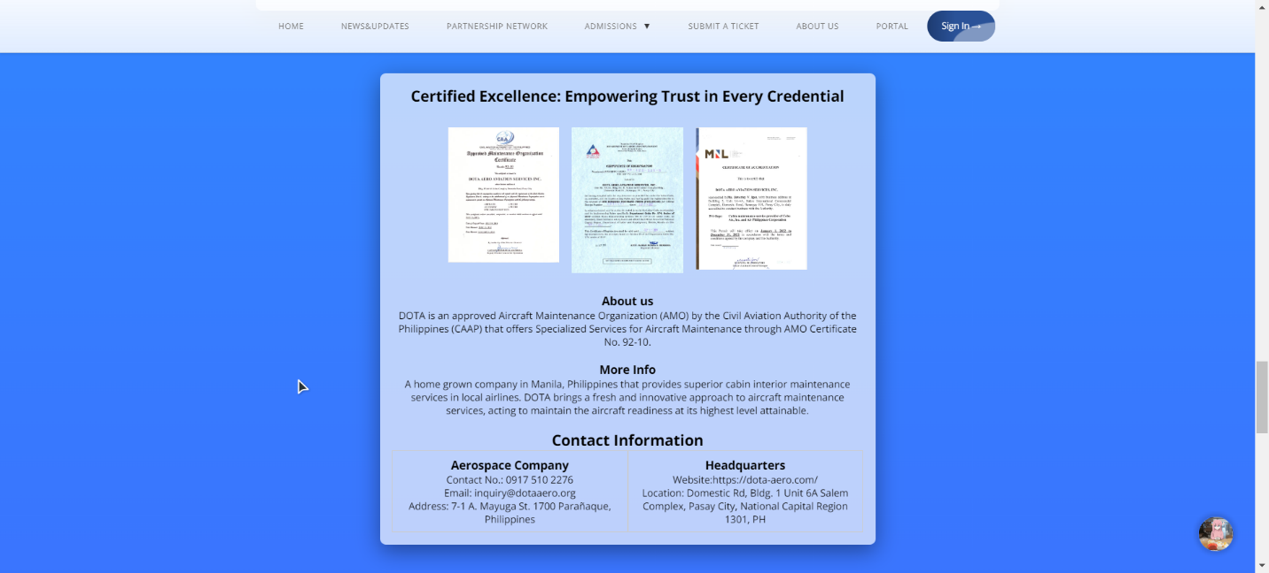



Information about the credentials are obtained from [DOTA Aero | (dota-aero.com)](https://dota-aero.com/)

**5. OJT ADMISSION/REGISTER**

Presents a structured multi-step form for OJT application. Step 01 outlines data privacy principles and includes a consent checkbox. Step 02 lists required documents with accompanying images and a download option. Step 03 confirms submission, triggering a success pop-up with a proceed button. The design aims to guide users efficiently through the application process while emphasizing data privacy compliance. It also contains the internship application form where ojt applicants will input and upload their information.

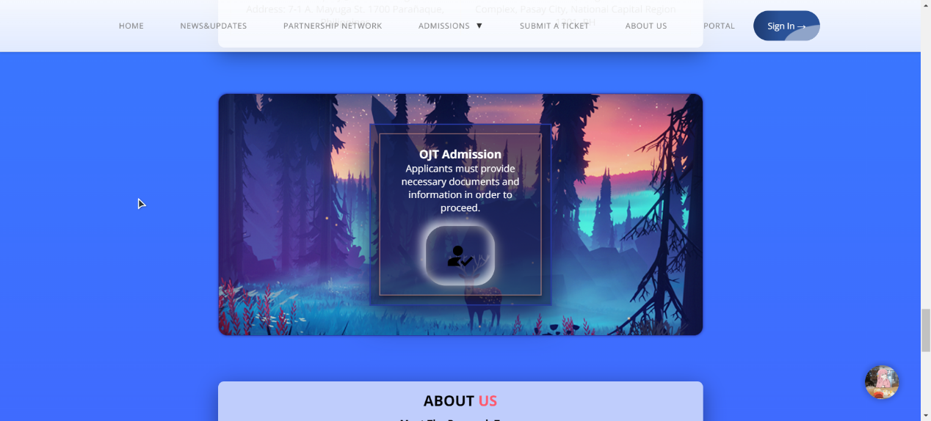

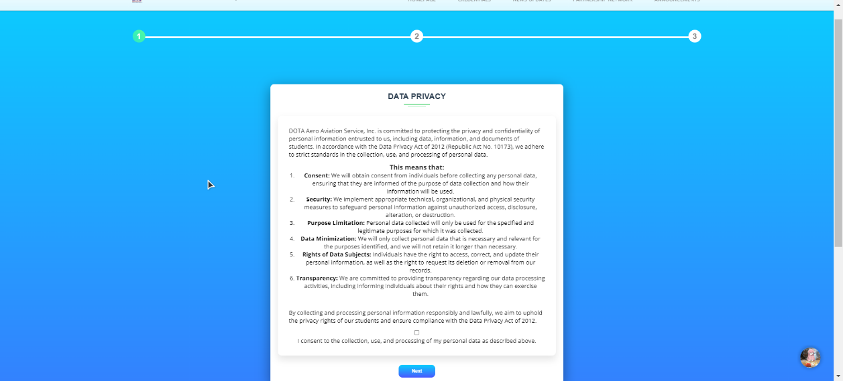

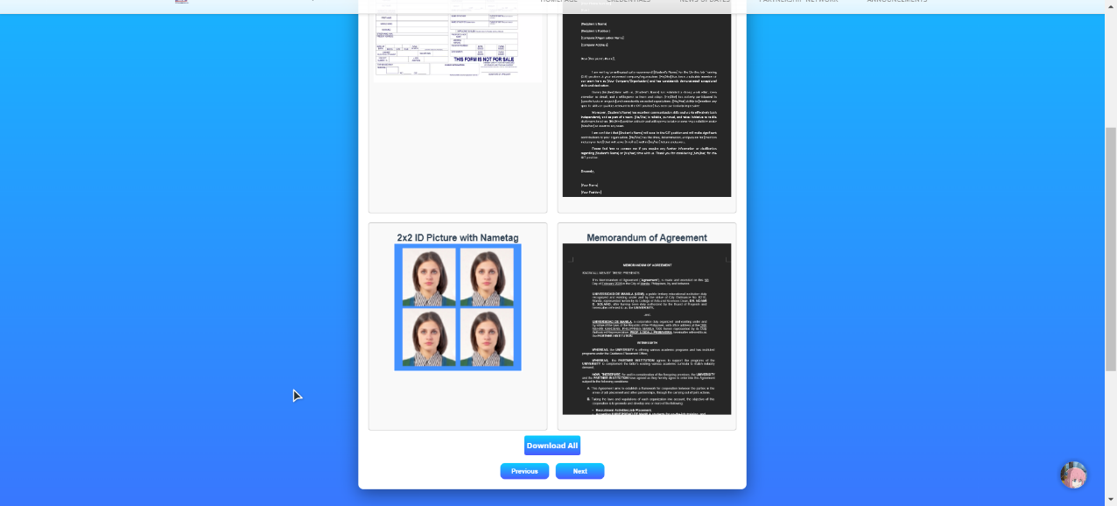

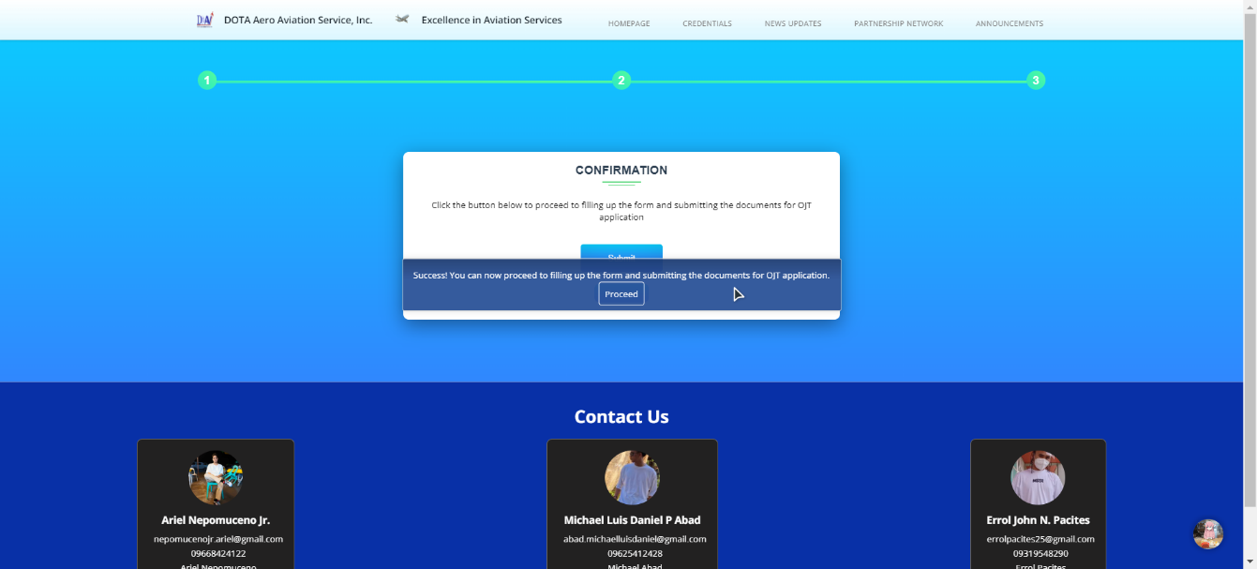

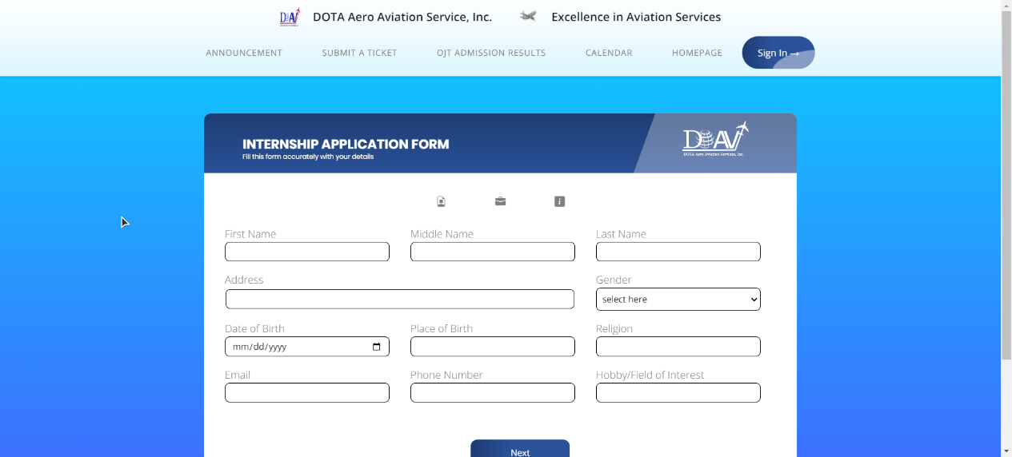

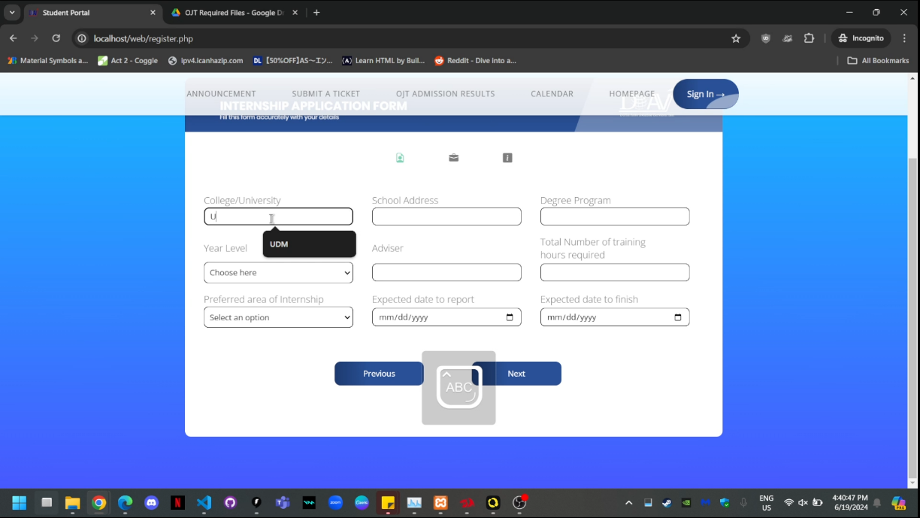

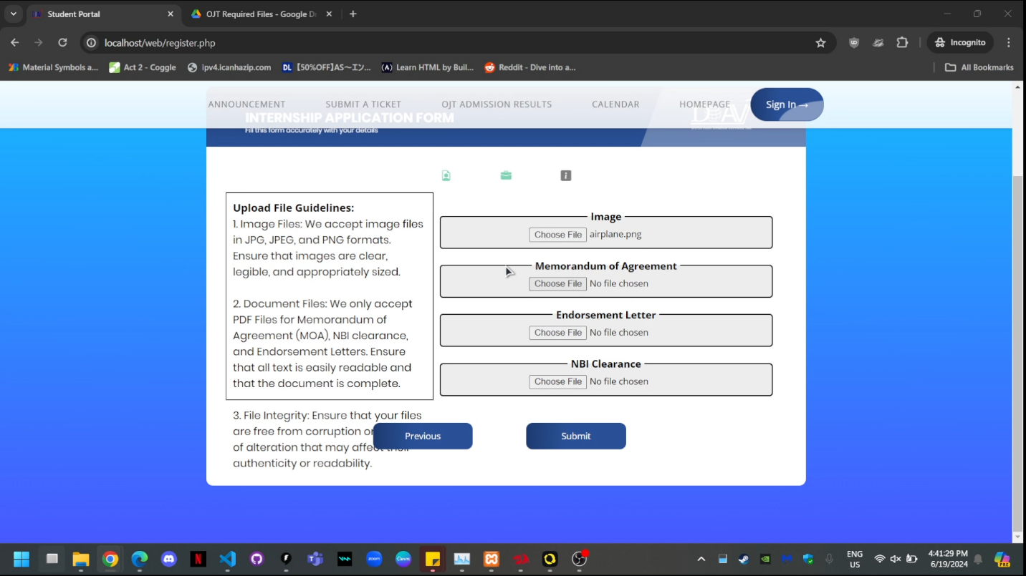

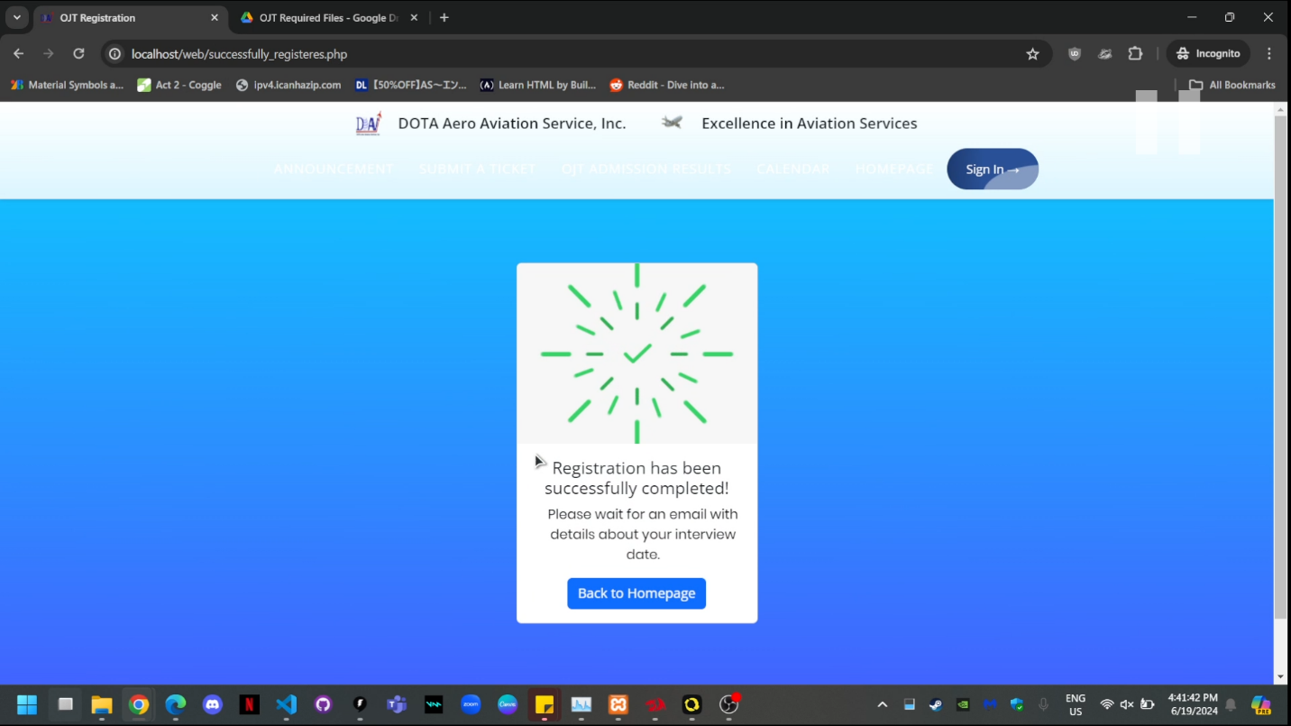

**6. OJT ADMISSION RESULTS**

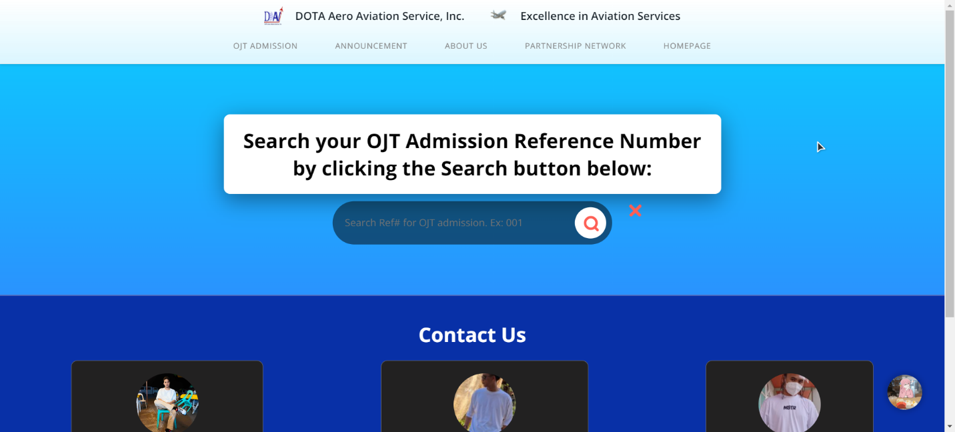

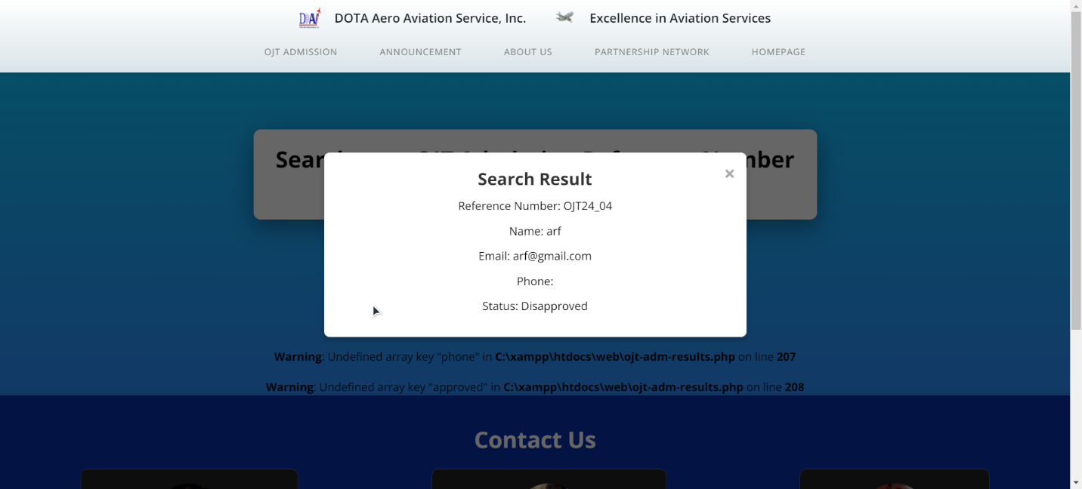

Serves as a webpage for users to search for their OJT (On-the-Job Training) admission results within a web application, the main content prompts users to search for their OJT admission results by entering their reference number. Provides a search input field and a search button, it also displays the search results once the user inputs their reference number. Finally, it includes a message indicating that the results will be displayed after the user searches for their reference number.

**7. Submit a ticket**

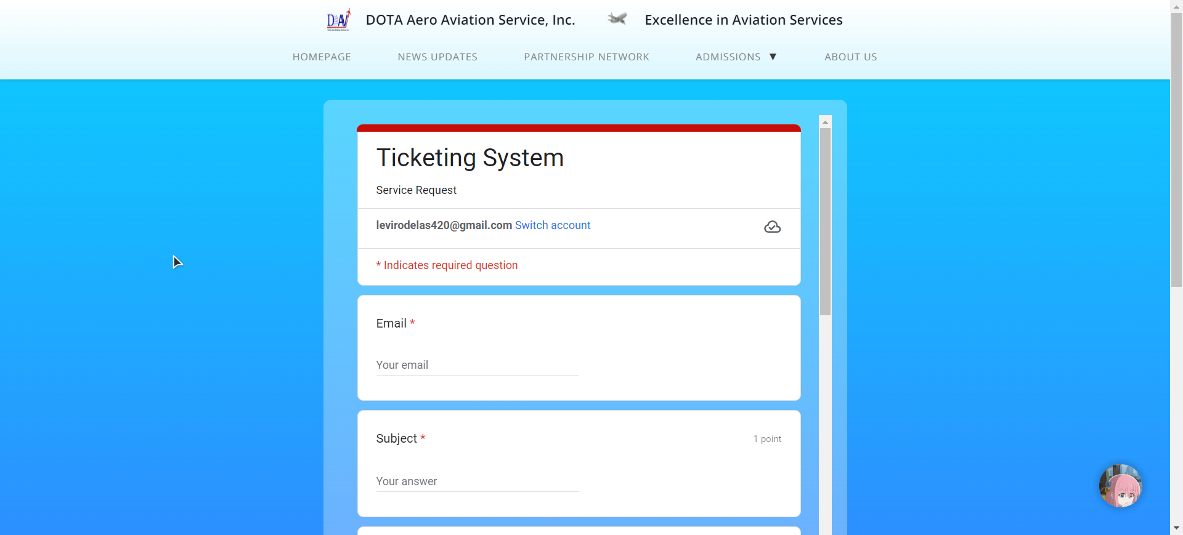

A webpage for submitting tickets. The main content of the page is an embedded Google Form within an iframe, allowing users to submit tickets. JavaScript code is included to toggle the navigation menu. Additionally, there's asynchronous drift code for messaging if you have concerns.

**8. About us**

Contains the information of the researchers who made the system.

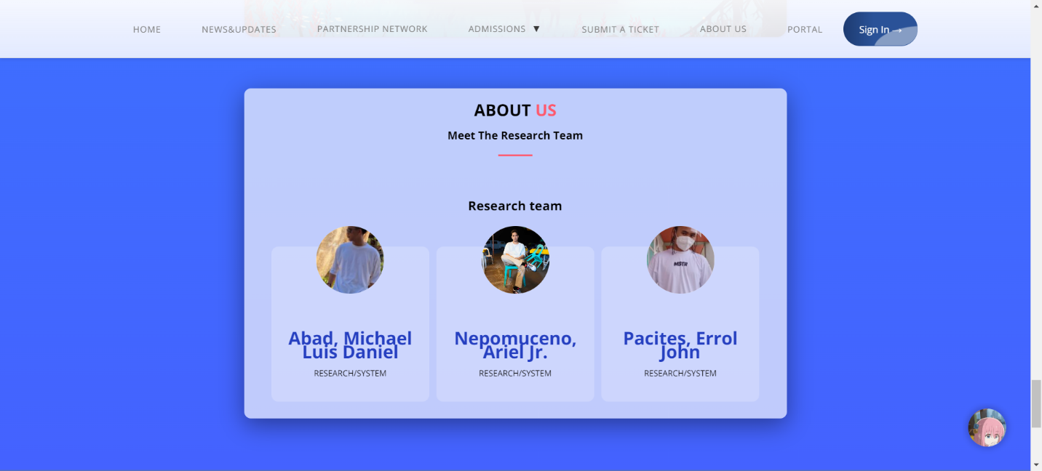

**9. Live chat**

A live chat is obviously needed when something goes wrong, so when the ojt applicant have an inquiry like forgetting the password, general questions and knowing the admission results, they will go to the live chat.

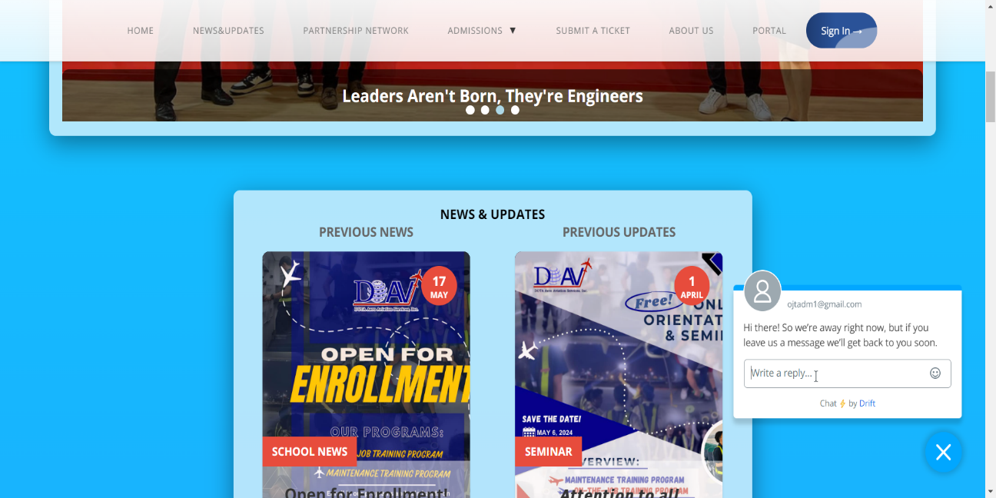

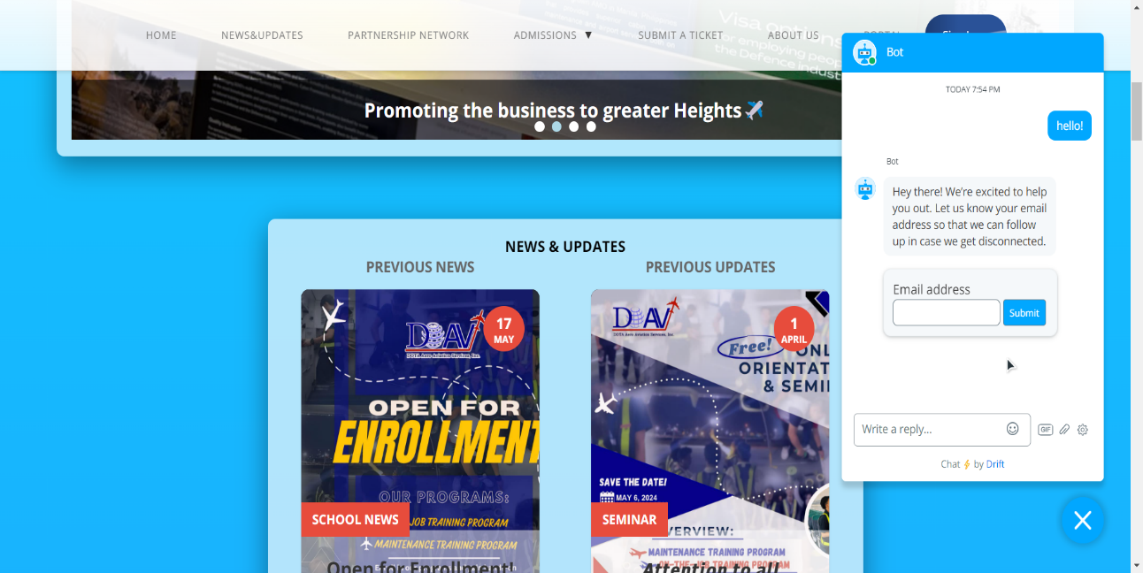

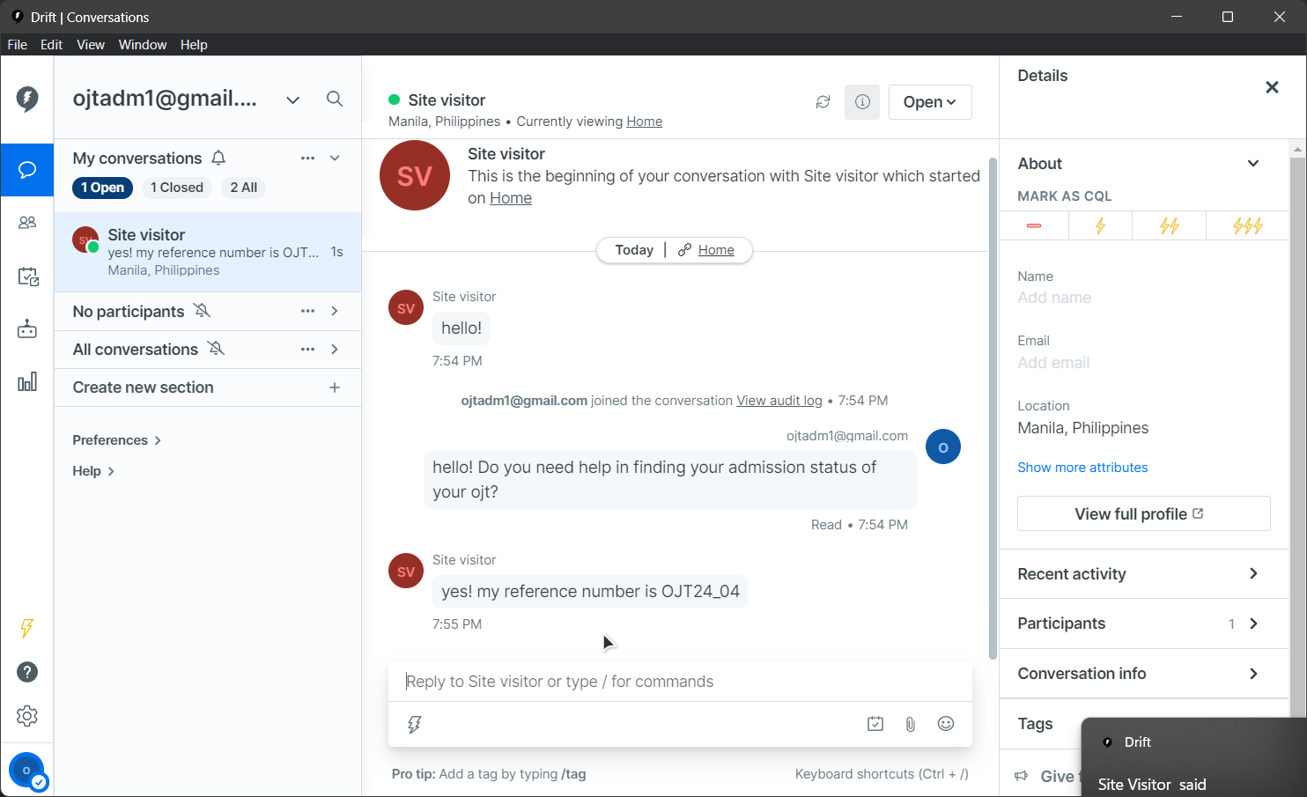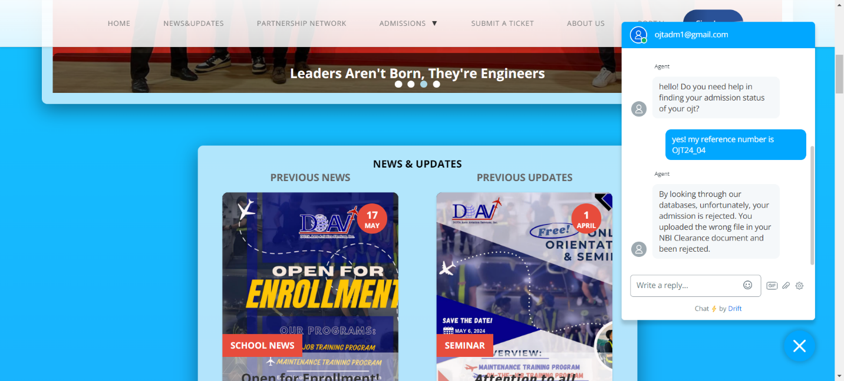

**10. Portal**

The portal is the heart for the approved ojt admission takers, so we made a dashboard for them with everything they need like the dashboard for ojt that consists of applicant information, ojt information, announcement panel, applicant progress in profile, task tracker, calendar panel, and the weather. It also shows the individual webpage for announcement, account settings, calendar and the homepage.

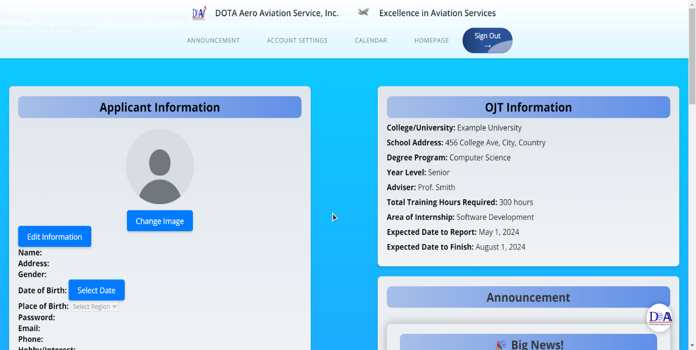

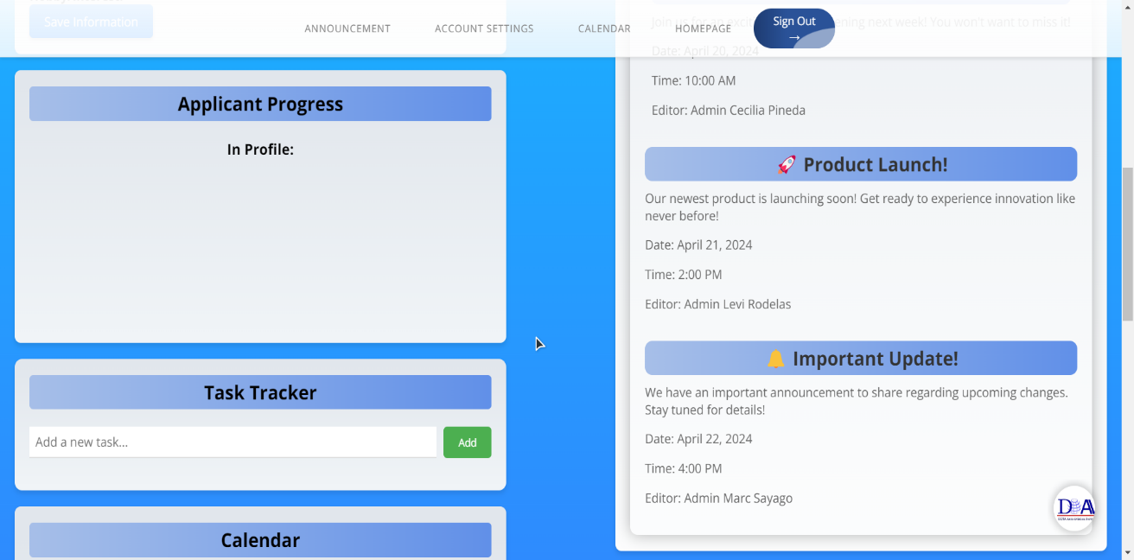

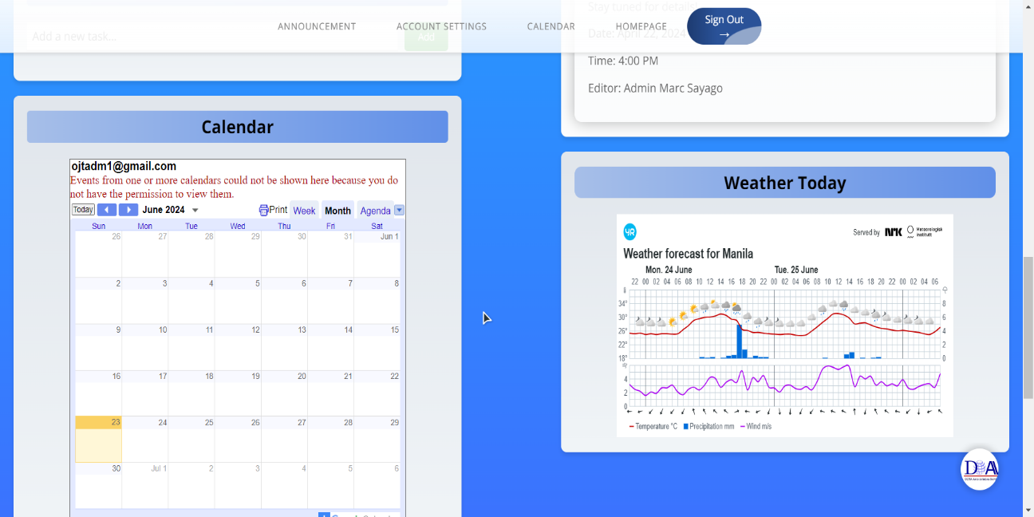

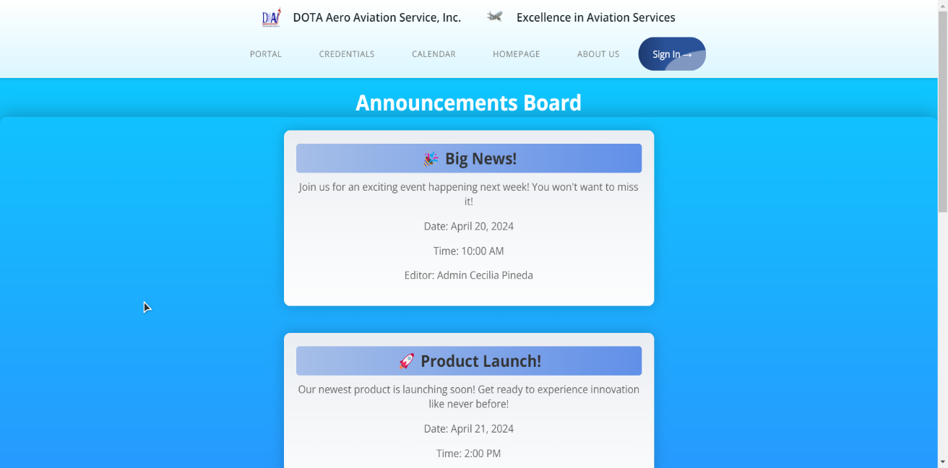

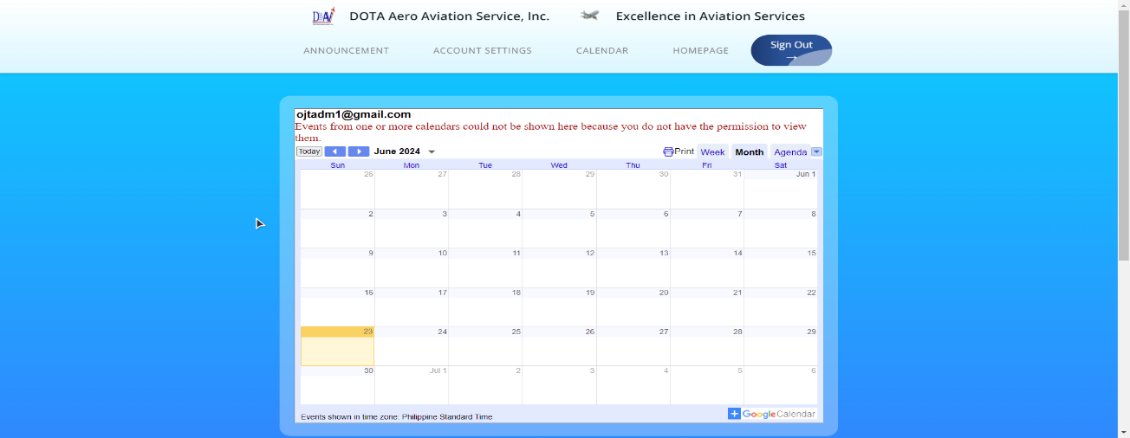

**11. Google Calendar**

This webpage shows the current and future events from the admins account



12. Announcements

This webpage shows the present and furure announcements/news that have updated by the system admins.



13. Login

The login page of the system serves as the login hub for the ojt applicants (if approved) and for the admin of the system. If the ojt applicant is logged in, they will go to the landing page and they can click the portal, while if the admin are logged in, the system will redirect it to the admin-profile which contains the admin related stuff like dashboard, tables, and their profile.

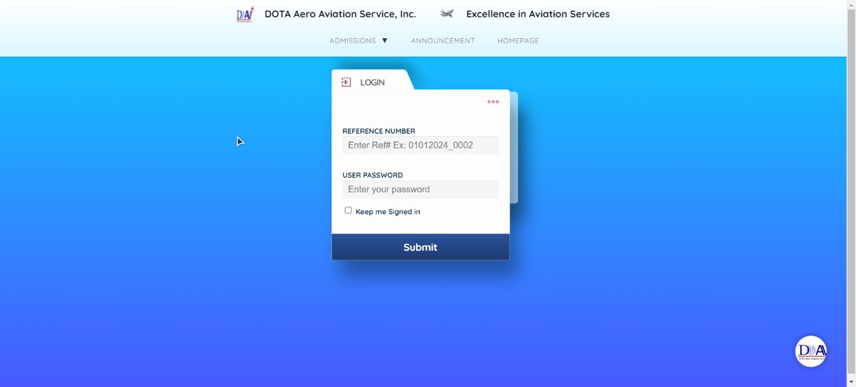

14. Admin

Admin contains the admin profile, sign out, dashboard and the tables. Tables are for rejecting/accepting ojt applicants, dashboard shows how many approved/rejected applicants etc, admin profile serves as the hub for their profile and an href for going to localhost/phpMyAdmin to manage the database of the system.

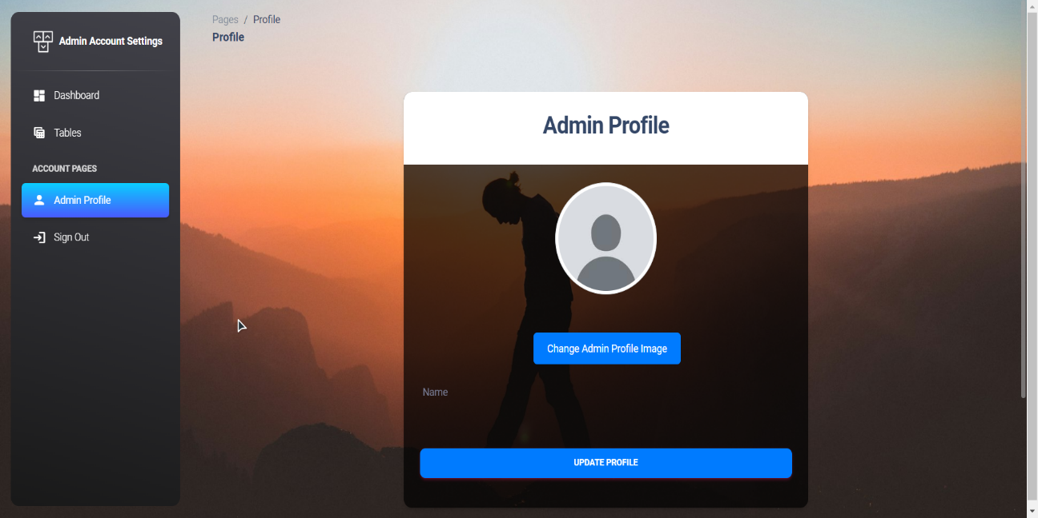

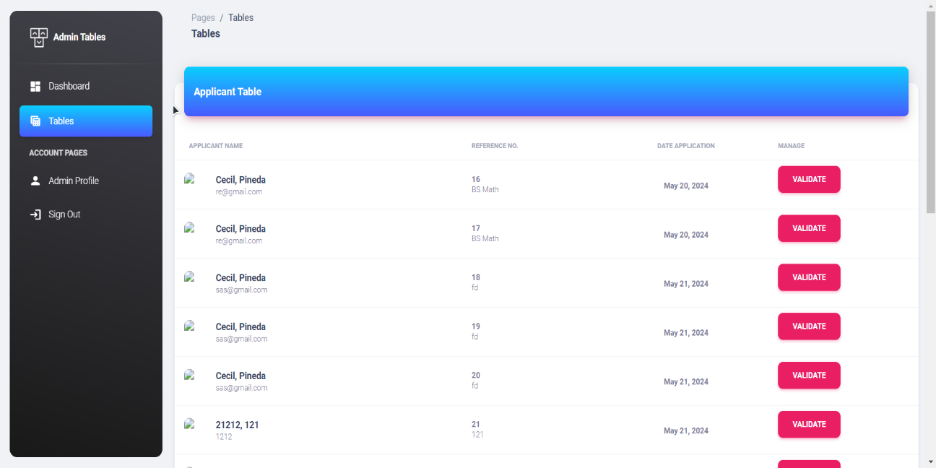

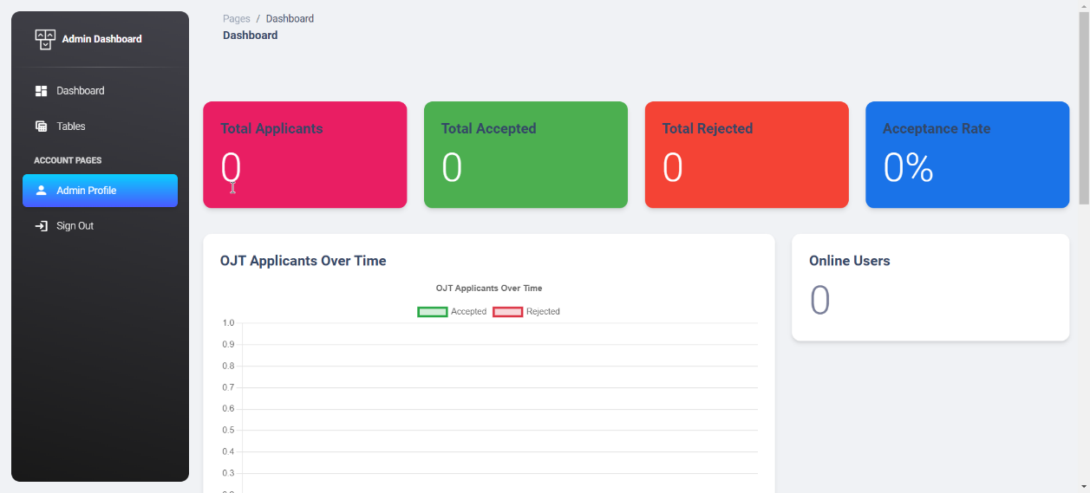

In addition to the mentioned features, the " **Web Based Online Application Management for OJT Applicants in Dota Aero Aviation Corporation**" also supports a mobile view of the website, ensuring a responsive and user-friendly experience for users accessing the system from their mobile devices.

Here are the key aspects of the mobile view support:

**1. Responsive Design:** The website is designed using responsive web design techniques. This means that the layout, elements, and content of the system automatically adjust to fit different screen sizes, including smartphones and tablets. The responsive design ensures optimal viewing and interaction, regardless of the device being used.

**2. Mobile-Friendly Navigation:** The navigation menu and other interactive components are optimized for mobile devices. The menu may transform into a collapsible or slide-out menu, providing an intuitive and efficient way for users to navigate through the system’s sections and features on smaller screens.

**Database Backend: MySQL**

This includes the whole database for the system

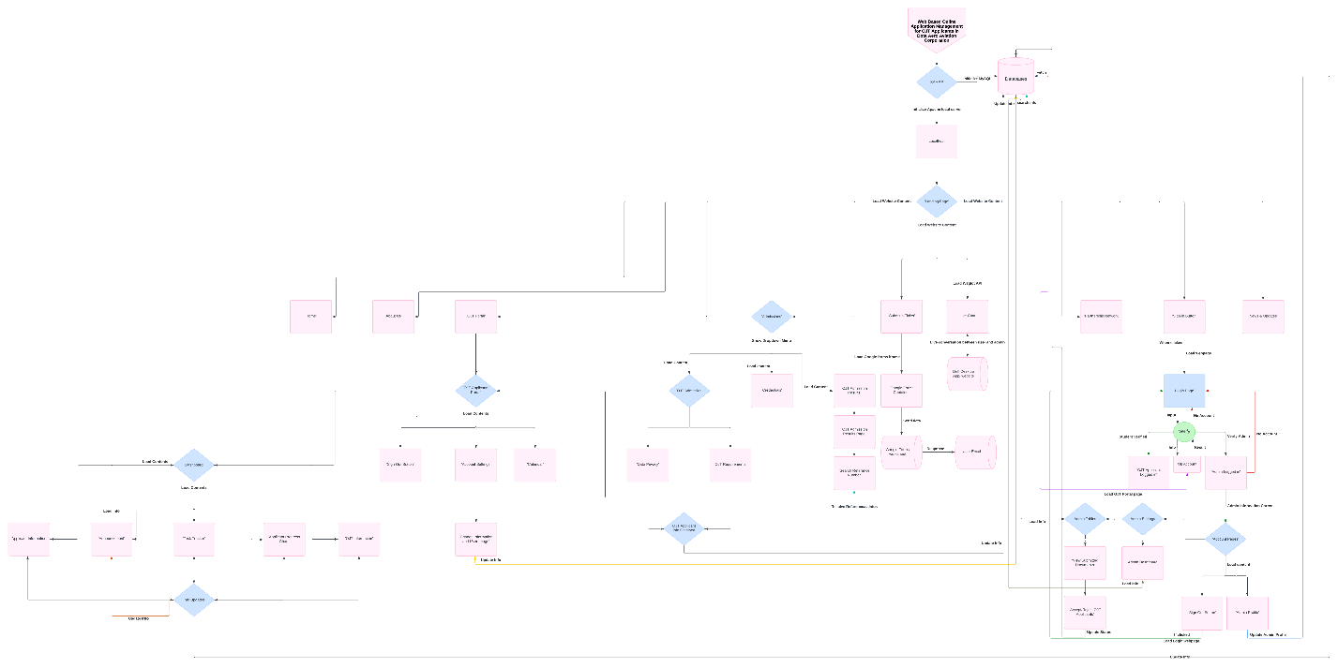

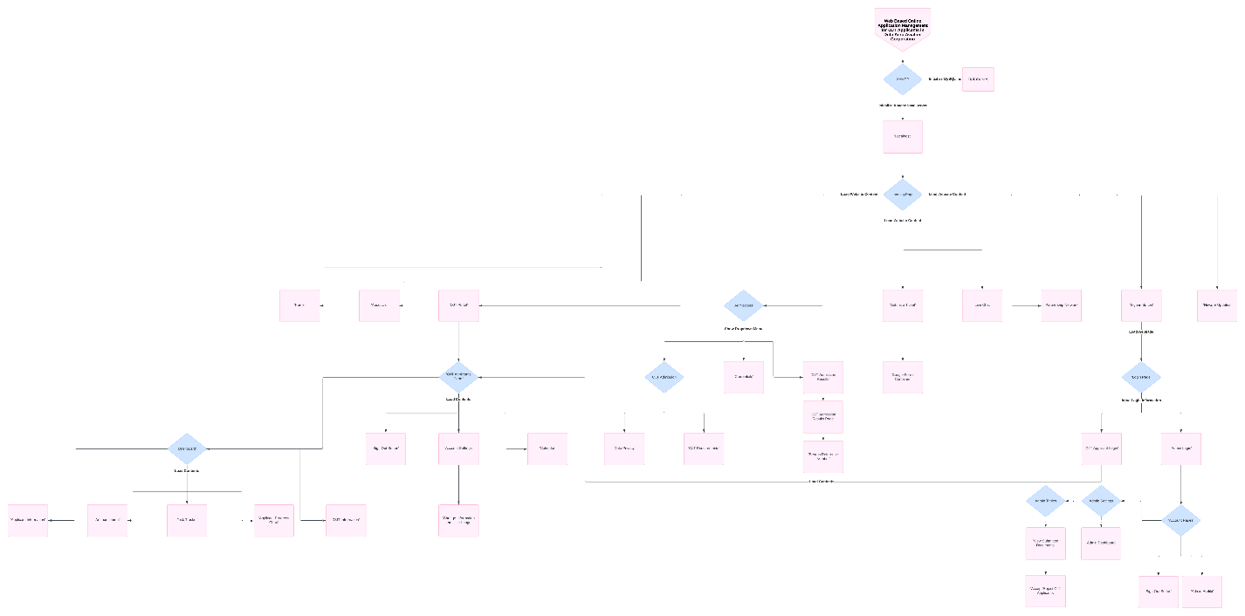

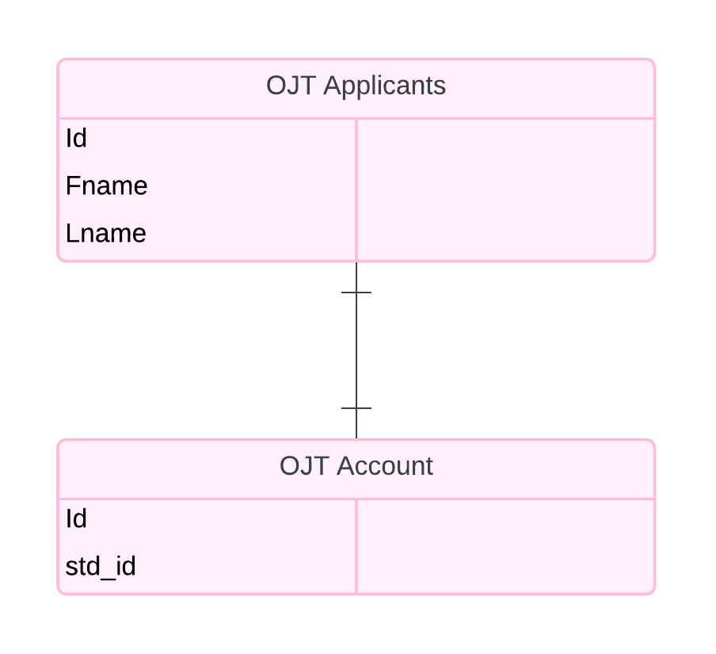

(goto the gdrive to see the higher resolution of the image and the documents for this)

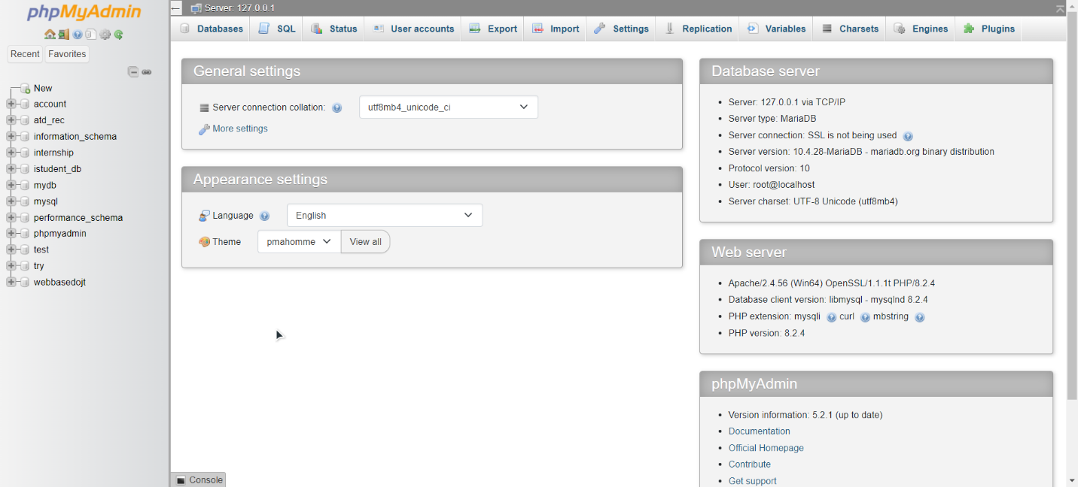

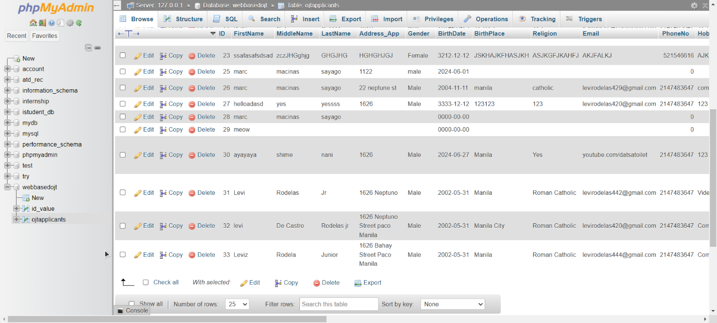

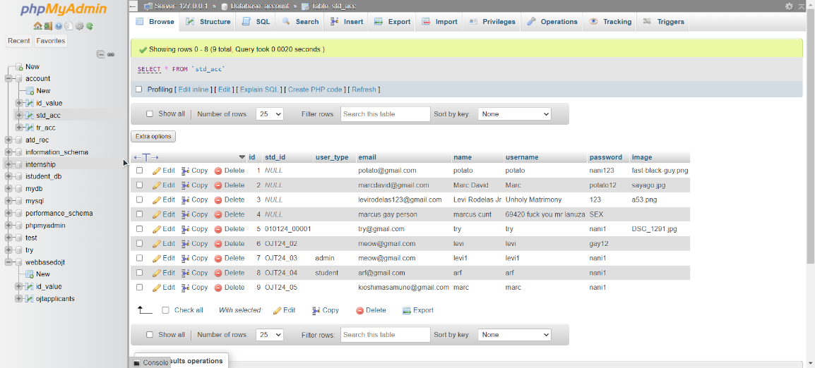

**Installation of XAMPP**

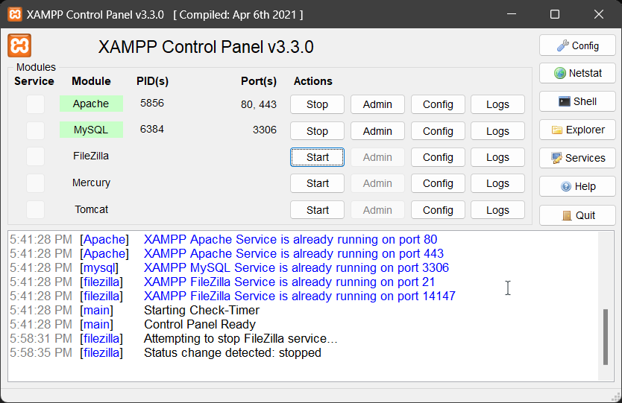

Download Link: <https://sourceforge.net/projects/xampp/files/XAMPP%20Windows/8.0.30/xampp-windows-x64-8.0.30-0-VS16-installer.exe>

**Installation of DRIFT (LIVE CHAT)**

**DRIFT (LIVE CHAT)**

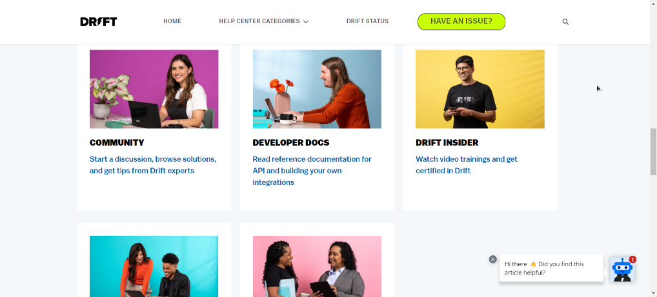

Download Link: <https://drift-prod-desktop-installers.s3.amazonaws.com/win/DriftSetup-latest.exe>

On the DRIFT (LIVE CHAT), to chat with the applicants, download the DRIFT CHAT APPLICATION AND USE THIS LOGIN INFORMATION

IF THE PANELIST WANTS TO KNOW IF THE LIVE CHAT WORKS, DO THIS STEPS BELOW:

**LOGIN INFO:**

To login: <https://start.drift.com/login>

(Click sign in with Google if you used [ojtadm1@gmail.com](mailto:ojtadm1@gmail.com) login information)

**Website login:**

Goto: <https://app.drift.com/home/dashboard>

And just sign in using your [ojtadm1@gmail.com](mailto:ojtadm1@gmail.com) (sign in with google)

If there is a new visitor just chat with them.

**PC app installation & login:**

DOWNLOAD THE APP:  
<https://drift-prod-desktop-installers.s3.amazonaws.com/win/DriftSetup-latest.exe>

SETUP THE APP:

. Go to your download page and Double click the exe file



. Let it install

. Login in to your drift account using google [ojtadm1@gmail.com](mailto:ojtadm1@gmail.com) (don’t forget to login to the google account first)

. new conversations will automatically appear if someone chatted on the live chat.

**Installation of VSCODE (Code editor IDE)**

**VS CODE**

Download link: <https://code.visualstudio.com/sha/download?build=stable&os=win32-x64-user>

Note: only use vscode if you want to edit the codes of our system.

Setup vscode:



**Setting up XAMPP for the system**

**Initializing the system to xampp**

**1.** Make sure you have downloaded and installed xampp.

2. Put the web folder to the htdocs of xampp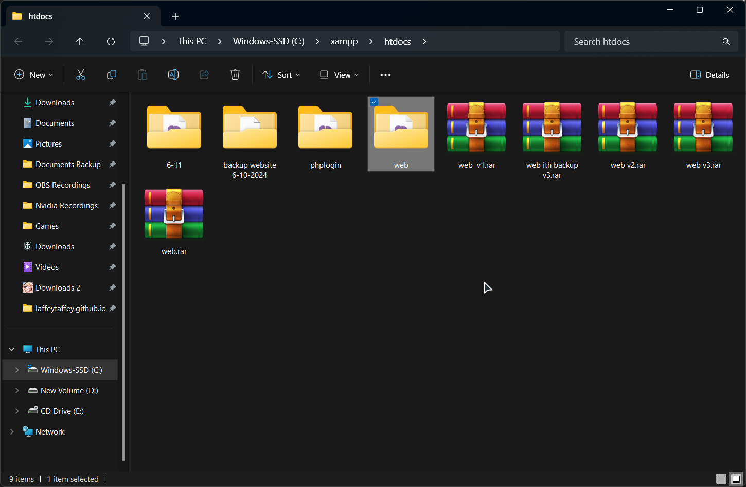

3. Go to your xampp control panel and click start on apache and mysql. If UAC are initiated, kindly click yes to make the localserver and the databases start.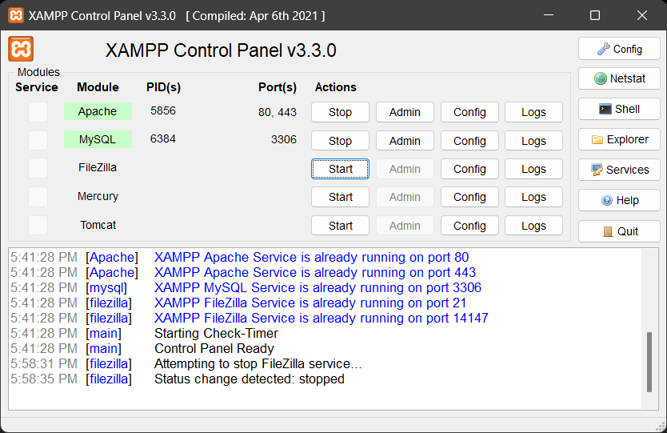

4. If the system starts successfully, go to your favorite browser (preferred chrome or browsers that uses chromium) and type in your address bar “localhost/web/landing.php” if done so, this will appear:

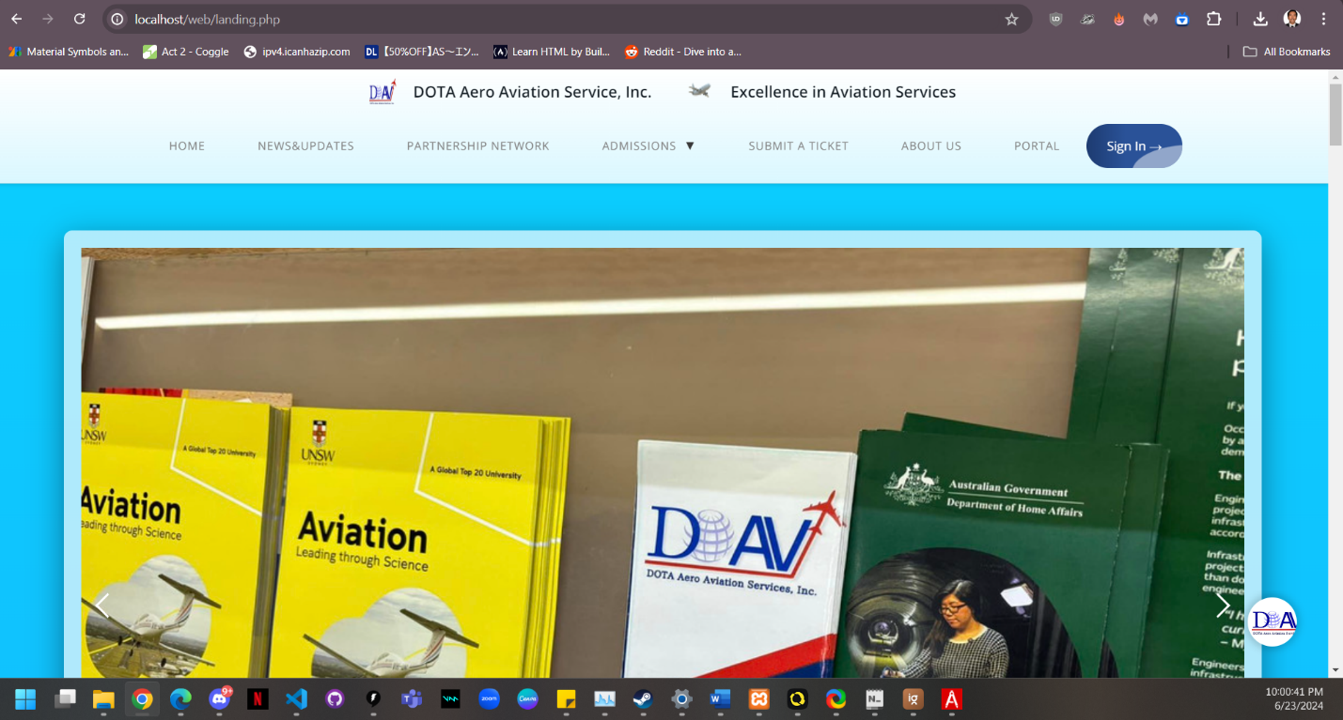

5. If you want to go to the admin page (which you must be logged in to go to the admin page), type in to your web address “localhost/phpmyadmin” if done so, this should appear

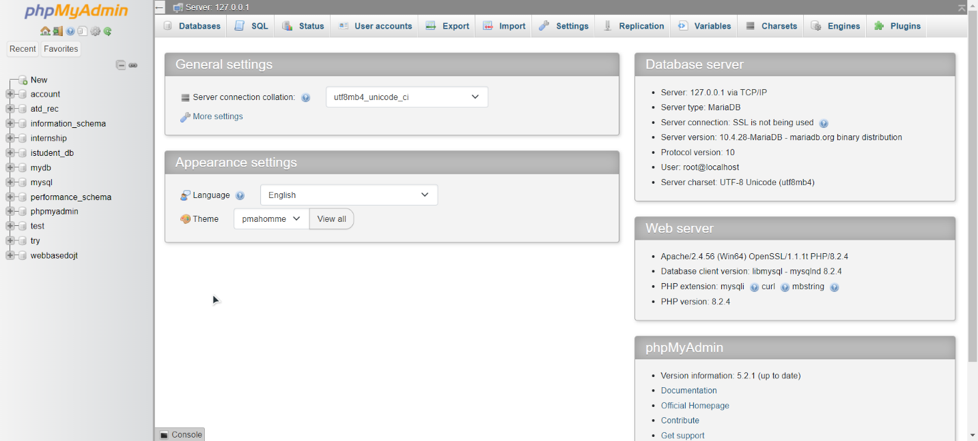

**PROGRAMMING LANGUAGES AND FRAMEWORKS USED**

The system for the "Web Based Online Application Management for OJT Applicants in Dota Aero Aviation Corporation" is built using the following programming languages:

1. **HTML:** HTML (Hypertext Markup Language) is used for structuring the content and creating the basic layout of the website. It provides the necessary elements and tags to define the structure of web pages.

2. **JavaScript:** JavaScript is utilized for scripting and adding interactivity to the website. It enables dynamic behavior, event handling, form validation, and other client-side functionalities that enhance the user experience.

3. **CSS:** CSS (Cascading Style Sheets) is employed for styling and designing the website. It is responsible for defining the visual appearance, layout, colors, fonts, and other aesthetic aspects of the web pages.

**4. PHP**: All of the HTML files have been converted to php files to enable php contents for the system.

5. **SCSS/SASS:** Sass/SCSS in Bootstrap allows for more efficient and organized CSS by providing features like variables, nested rules, and mixins, which streamline styling and make it easier to maintain. It also enables easy customization of Bootstrap's design system, allowing us to tailor the framework to the specific design requirements.

**Frameworks**

**1. BOOTSTRAP (v5):** We have used bootstrap to familiarize and take a look at bootstrap since it helps us type less and integrate better UI elements for the system rather than using pure html, css and javascript.

**Applications used for creating the system**

**Visual Studio Code (VSCODE)**

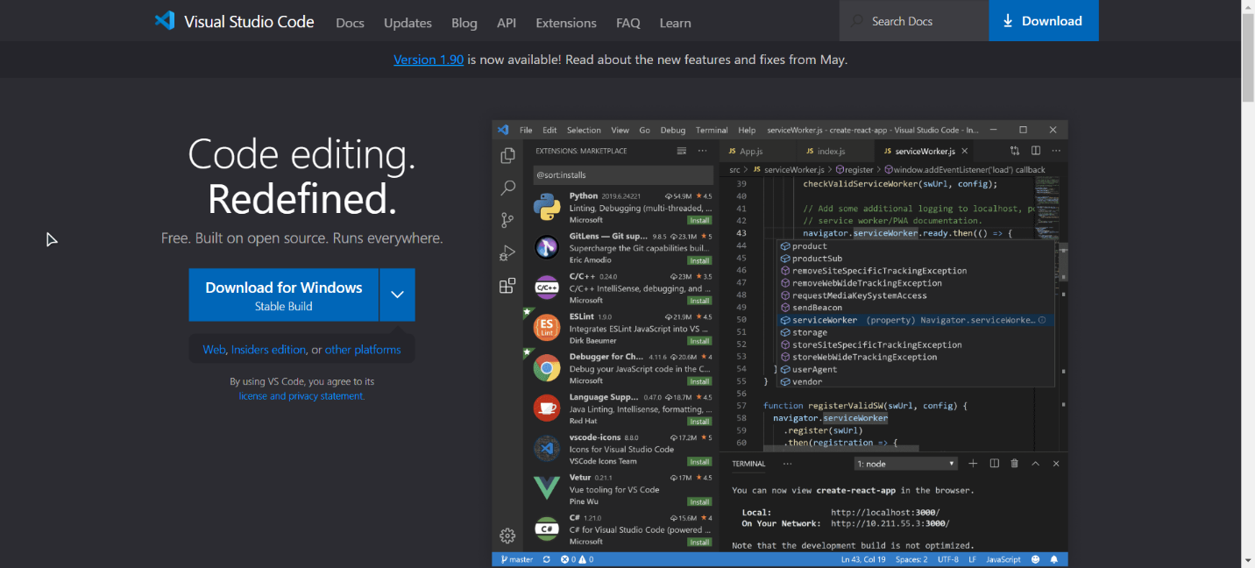

Download Link: <https://code.visualstudio.com/sha/download?build=stable&os=win32-x64-user>

### Step 1: Download VS Code

1. Visit the [official Visual Studio Code website](https://code.visualstudio.com/).
2. Click on the download button for your operating system (Windows, macOS, or Linux).

### Step 2: Install VS Code on Windows

1. Locate the downloaded installer file (usually in your Downloads folder) and double-click it to run.
2. Follow the steps in the installation wizard:
   * **License Agreement**: Accept the license agreement and click "Next".
   * **Select Destination Location**: Choose the destination folder where you want to install VS Code. The default is usually fine. Click "Next".
   * **Select Additional Tasks**: Choose additional tasks such as creating a desktop icon, adding to the PATH, and registering VS Code as the default editor for supported file types. It's recommended to check the options for adding to the PATH and registering as the default editor. Click "Next".
   * **Ready to Install**: Click "Install" to begin the installation.
3. Wait for the installation to complete. Once done, you can launch VS Code by checking the box that says "Launch Visual Studio Code" and clicking "Finish".

**XAMPP**



Download Link: <https://sourceforge.net/projects/xampp/files/XAMPP%20Windows/8.0.30/xampp-windows-x64-8.0.30-0-VS16-installer.exe>

**Step 1: Download XAMPP**

1. Visit the official XAMPP website.
2. Choose the version of XAMPP that corresponds to your operating system (Windows, macOS, or Linux).
3. Click on the download link to start downloading the installer.

**Step 2: Install XAMPP on Windows**

1. Locate the downloaded installer file (usually in your Downloads folder) and double-click it to run.
2. If prompted by User Account Control, click "Yes" to allow the installation to proceed.
3. Follow the steps in the installation wizard:
   * **Welcome Screen**: Click "Next".
   * **Select Components**: Choose the components you want to install. By default, all components are selected. It's usually safe to leave the default selections and click "Next".
   * **Installation Folder**: Choose the folder where you want to install XAMPP. The default is usually C:\xampp. Click "Next".
   * **Bitnami for XAMPP**: You can skip this by unchecking the box and clicking "Next".
   * **Ready to Install**: Click "Next" to start the installation process.
4. Wait for the installation to complete. This may take a few minutes.
5. Once the installation is finished, you can start the XAMPP Control Panel by checking the box that says "Do you want to start the Control Panel now?" and clicking "Finish".

**DRIFT (LIVE CHAT)**

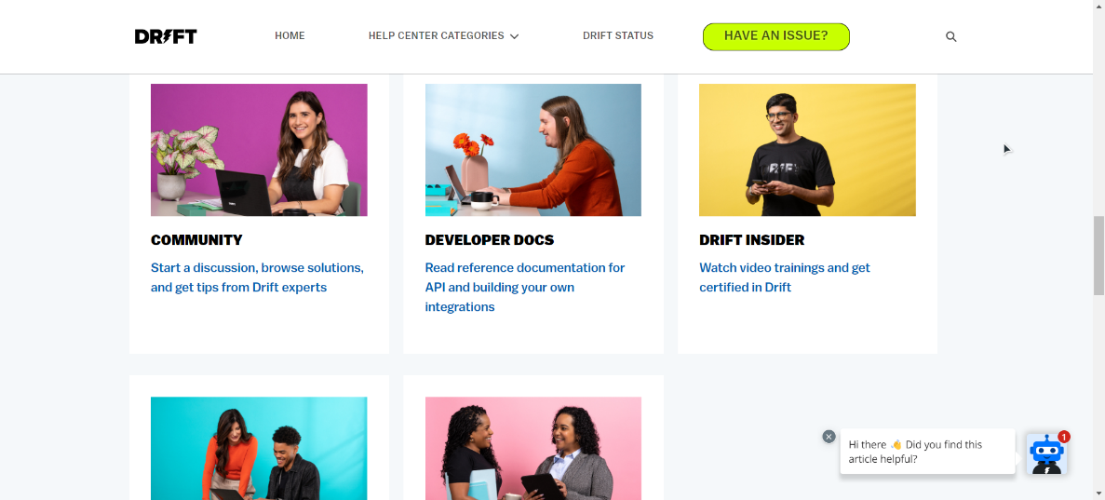

Download Link: <https://drift-prod-desktop-installers.s3.amazonaws.com/win/DriftSetup-latest.exe>

On the DRIFT (LIVE CHAT), to chat with the applicants, download the DRIFT CHAT APPLICATION AND USE THIS LOGIN INFORMATION

IF THE PANELIST WANTS TO KNOW IF THE LIVE CHAT WORKS, DO THIS STEPS BELOW:

**LOGIN INFO:**

To login: <https://start.drift.com/login>

(Click sign in with Google if you used [ojtadm1@gmail.com](mailto:ojtadm1@gmail.com) login information)

**Website login:**

Goto: <https://app.drift.com/home/dashboard>

And just sign in using your [ojtadm1@gmail.com](mailto:ojtadm1@gmail.com) (sign in with google)

If there is a new visitor just chat with them.

**PC app installation & login:**

DOWNLOAD THE APP:  
<https://drift-prod-desktop-installers.s3.amazonaws.com/win/DriftSetup-latest.exe>

SETUP THE APP:

. Go to your download page and Double click the exe file



. Let it install

. Login in to your drift account using google [ojtadm1@gmail.com](mailto:ojtadm1@gmail.com) (don’t forget to login to the google account first)

. new conversations will automatically appear if someone chatted on the live chat.

**System Performance Testing**

**Lighthouse**

Using lighthouse gives us a better understanding how the performance of the system does during loading times and event handling by analyzing each page load of the system.

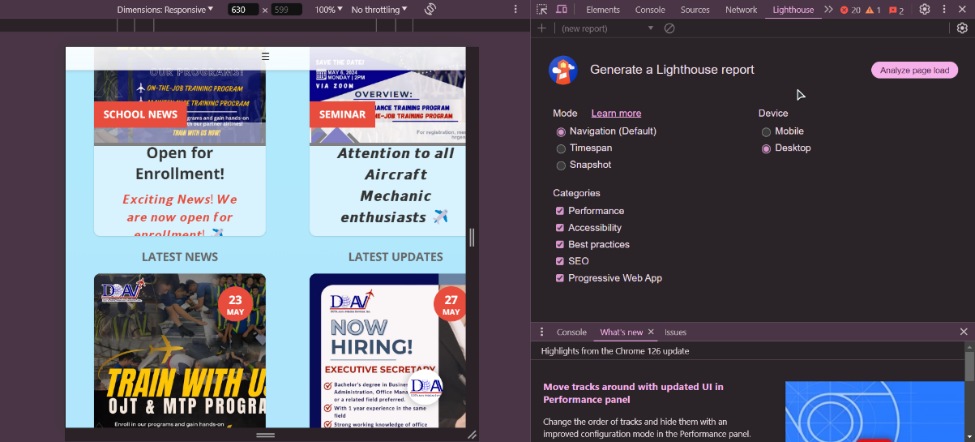

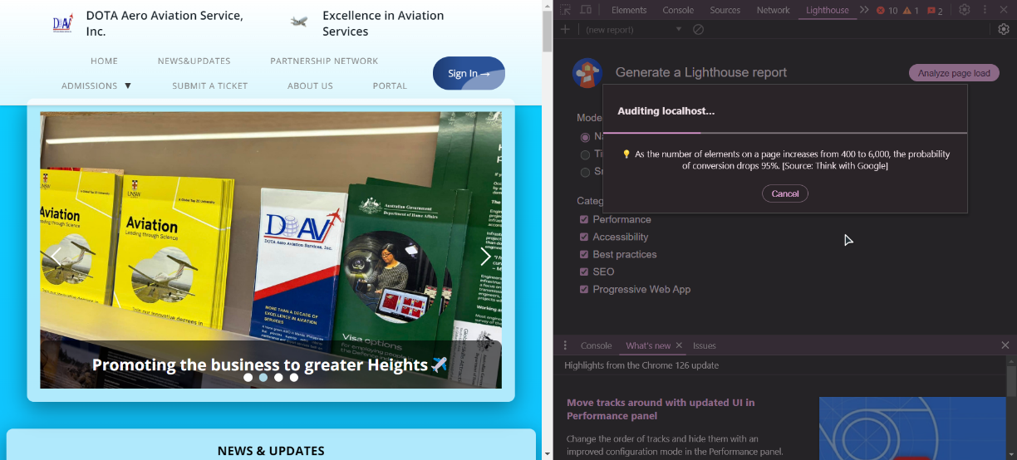

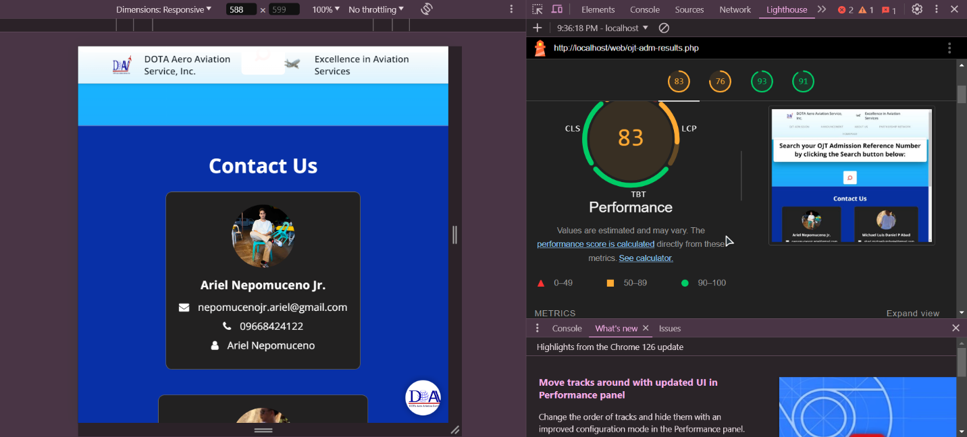

**APIs**

The " **Web Based Online Application Management for OJT Applicants in Dota Aero Aviation Corporation**" integrates several APIs to enhance its functionality and provide additional content and features. Here are the APIs used:

**1. Drift API**: The Drift API is employed for implementing the live chat system on the website. Drift is a customer messaging platform that allows real-time communication between users and support agents. By utilizing the Drift API, the portal enables students to engage in live chat conversations with support agents or automated bots for immediate assistance and support.

